Appendix A: Comparing previously generated (“old”) coastal and freshwater pond station scores against R program (“new”) scores

To validate the R program outputs, APCC conducted a full reconciliation of methods—comparing TSI (freshwater) and EI (coastal) scores produced by the new R workflow with those generated by the prior Excel-based process. Where results diverged, APCC reviewed underlying records to determine the cause. The detailed findings and common sources of difference are summarized below. Overall, the evaluation shows that the scripted R workflow improves accuracy, consistency, and reproducibility while reducing opportunities for human error.

New vs. Old EI Score Comparison

Figure 1 compares EI station scores from the current R-based workflow with the prior Excel-derived scores. On average, the R method yields slightly lower values, but overall agreement is strong. Because the Buzzards Bay Coalition (BBC) publishes EI scores for its stations, APCC also compared R-generated outputs to BBC’s scores; results were closely aligned (pink points in Fig. 1a). Relative differences between the old and new scores were typically <20% (Fig. 1b), with a small number of annual outliers traced to legacy data-selection errors in the manual process.

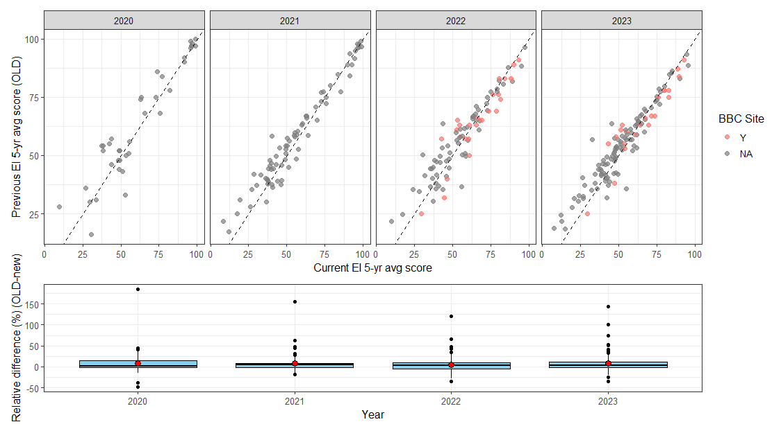
(a)
(b)
Figure 1: Scatter plot (a) and box plot (b) produced to compare the EI scores produced by the newly developed R program (current method) against the previous method whereby scores were calculated manually in Microsoft Excel. The pink dots indicate a comparison between scores previously provided by Buzzards Bay Coalition against APCC current method; all others previous scores were generated by APCC. Relative percent difference is derived from the absolute difference between the old and new scores divided by the sum of the two values and multiplied by 100.

While a few outliers were traced to human error, the remaining ~20% relative difference observed more broadly reflects minor method updates in the new workflow. First, the prior process calculated theoretical dissolved oxygen by treating missing salinity values as zeros, which biased results. The R program corrects this by not computing theoretical DO when salinity is missing (and using measured salinity when it is available).

Second, the new program is incorporating substantially more data into the final calculations because it is pulling from an export from the Cape Cod Water Quality Data Portal. In the past, data was typically sourced from one provider (E.g., UMASS Dartmouth School for Marine Science and Technology, SMAST) to generate scores, but with access to the larger dataset, the scores reflect data that could be collected by more than one monitoring program at the same station in the same year (e.g., SMAST and Center for Coastal Studies). This broader representation increases confidence in the results; however, the additional measurements can introduce more variability, so final scores may differ slightly from those produced previously.

Third, with multiple monitoring programs contributing data, sampling density differs by program—some collect a single surface sample while others take profiles through the water column at the same station and year. To treat these distinct sampling events consistently, we aggregate within a station-year using weighted averages (e.g., event-weighted as appropriate) so that profile datasets do not over-influence results relative to surface-only programs. This harmonized approach preserves information from intensive sampling while keeping comparisons fair, which can lead to small differences from earlier scores.

Lastly, in the past Particulate Organic Nitrogen was used as a substitute for Total Organic Nitrogen. However, after closer inspection into the relationship between these two components, due to poor correlation, this was not deemed a reasonable approach. This only changed scores for approximately 4% of the data.

The updated scoring approach delivers clearer, more dependable results. By running scripted calculations in R against standardized data exports, APCC applies the same rules every time, reducing opportunities for spreadsheet errors, and making the entire process faster to update. The code and parameters are fully documented, which improves transparency and makes reviews straightforward. Because these data now aggregate across monitoring programs, APCC can analyze more samples from more locations, giving a fuller picture of conditions and improving comparability across sites and years. While these refinements explain the roughly 20% relative difference seen in some station EI scores, they do not materially change the State of the Waters grades or the overall message about Cape Cod’s water quality.

New vs. Old TSI Score Comparison (2025)

Figure 2 shows the results from the comparison of TSI scores generated by the R program versus the previous Microsoft Excel method. Alignment between methods was strong. Discrepancies in 2022–2023 for several Orleans stations stemmed from a Secchi-depth selection error, and Barnstable dissolved-oxygen data were selected incorrectly in 2023–2024, affecting those scores. Overall, the relative percent difference was ~5%, with three cases approaching 10%. Aside from these human errors associated with the old method, no other systemic changes could be identified to account for discrepancies.

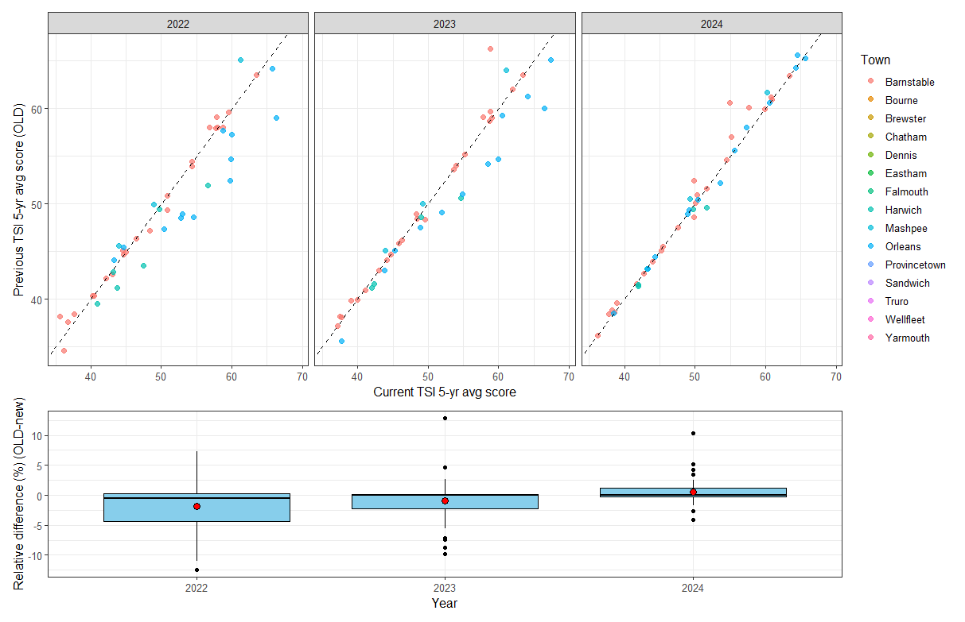
(b)
(a)
Figure 2: Scatter plot (a) and box plot (b) produced to compare the TSI scores produced by the newly developed R program (current method) against the previous method whereby scores were calculated manually in Microsoft Excel. Relative percent difference is derived from the absolute difference between the old and new scores divided by the sum of the two values and multiplied by 100. Colors represent the town where the stations are located.

